***Birthday Reminder Application***

*Welcome to the User Manual!*



**Submitted By:**

Hithansh H Shenoy (4NM21IS054 )

Hithesh Jain (4NM21IS055)

Atheeth Pai (4NM21IS030)

Darshan RM (4NM21IS041)

**Submitted To:**

Prof. Sapna S

Assistant professor, Department of IS

***TABLE OF CONTENTS :***

1. Introduction…………………………………………………………1
2. Home Screen……………………………………………………….2
3. Enter Details………………………………………………………..3
4. Select Date………………………………………………………….4
5. Select Time………………………………………………………….5
6. View Reminders…………………………………………………..6
7. Notification………………………………………………………….7
8. Conclusion…………………………………………………………..8

***1.Introduction :***

This manual aims to provide you with comprehensive guidance on using the Birthday Reminder Application on your Android device. By reading this guide carefully, you will gain a complete understanding of the app's features and functionalities, enabling you to make the most out of it.

About the Birthday Reminder Application:

The Birthday Reminder Application is a user-friendly Android-based reminder app, designed to assist you in managing and tracking birthdays effortlessly. With this application, you can set personalized notifications for birthdays on specific dates and times, ensuring you never miss an opportunity to celebrate with your loved ones.

How it Works:

When you click on the "Add Birthday" option, you initiate the process of creating a new birthday reminder. The application guides you through the steps to provide the necessary details. The user interface incorporates Android DatePicker and TimePicker controls for intuitive date and time selection. The app then utilizes the Alarm Manager to set reminders, and all the essential information is stored securely in the SQLite3 Database, allowing for efficient retrieval and management.

***2.Home Screen:***

Welcome to the Home Screen:

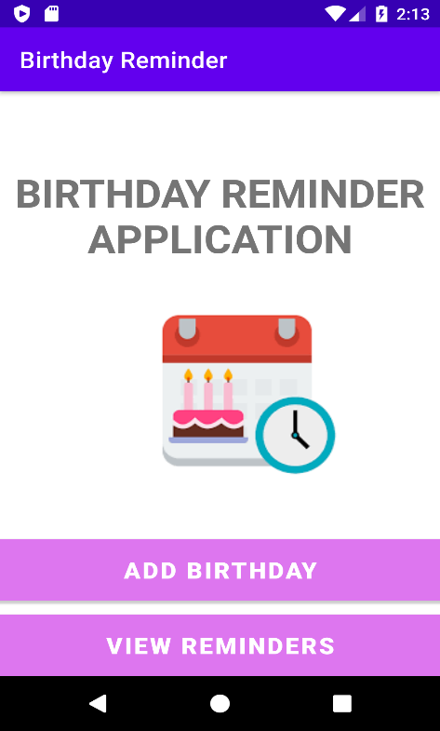

The Home Screen serves as the central hub for all your birthday reminders. It provides quick access to various features of the Birthday Reminder Application, making it easy for you to manage and view your reminders. Here are the key elements of the Home Screen:

Add Birthday: By tapping this button, you can create a new birthday reminder by entering the person's name and selecting the date and time.

View Reminders: This button allows you to access a list of all your saved birthday reminders, enabling you to review and modify them as needed.

Notification Settings: Customize your reminder notification preferences by adjusting settings for sound, vibration, or silent notifications, along with setting the frequency of reminders for multiple birthdays on the same day.

***3.Enter Details:***

Adding a New Birthday Reminder: Enter Details

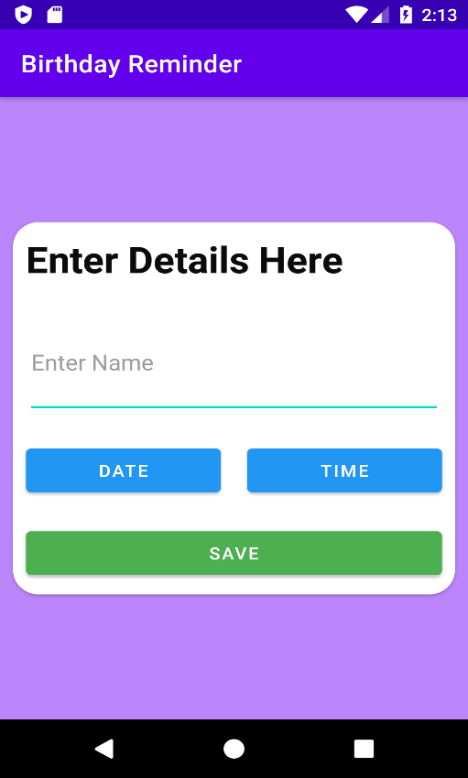

When you decide to add a new birthday reminder, follow these steps:

Tap on the "Add Birthday" button on the Home Screen to proceed to the "Enter Details" page.

On the "Enter Details" page, you will find fields to enter the name of the person whose birthday you want to be reminded of.

Utilize the DatePicker to easily select the date of the birthday by tapping on the day, month, and year fields.

Use the TimePicker to choose the precise time you wish to receive the reminder notification.

Once you have entered all the relevant details, tap the "Save" button to store the reminder securely in the app.

***4.Select Date:***

Selecting the Birthday Date:

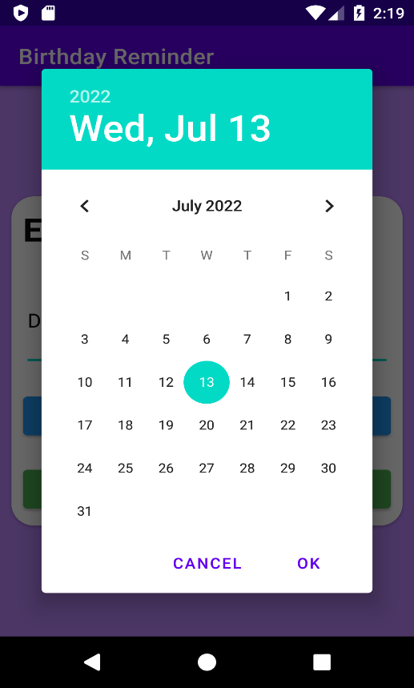

The "Select Date" page provides you with a user-friendly interface to choose the date for your birthday reminder. The DatePicker control simplifies the process:

Tap on the day field to access the day picker.

Tap on the month field to access the month picker.

Tap on the year field to access the year picker.

Select the desired date by interacting with the corresponding pickers.

***5.Select Time:***

Setting the Reminder Time:

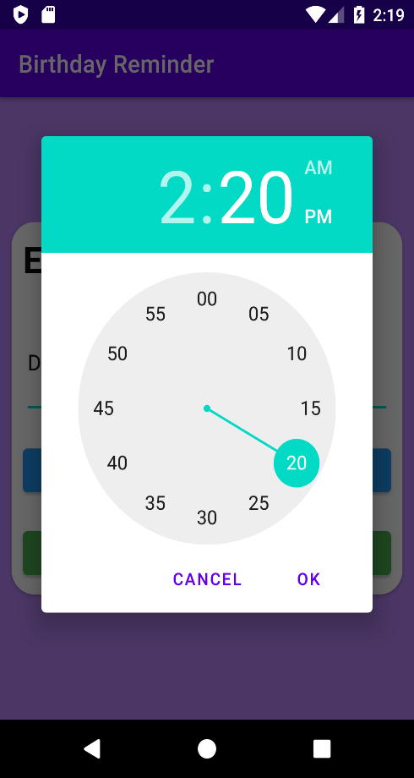

On the "Select Time" page, you can easily configure the time for receiving the birthday reminder notification. The TimePicker control facilitates this process:

Tap the hour field to access the hour picker.

Tap the minute field to access the minute picker.

Choose the time either in the 24-hour format or the AM/PM mode based on your preference.

***6.View Reminders:***

Viewing All Birthday Reminders:

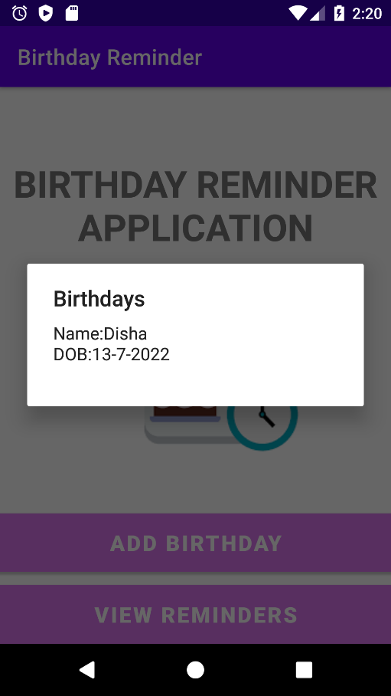

The "View Reminders" page displays a comprehensive list of all the birthday reminders you have saved in the app. Here, you can:

Edit: By tapping on a specific reminder, you can edit its details, such as the person's name, date, or time.

Delete: To remove a reminder, swipe left on the respective reminder entry.

Mark as Done: Once the birthday has passed, you can mark the reminder as done to keep your reminders organized and up to date.

***7.Notification:***

Notification Settings:

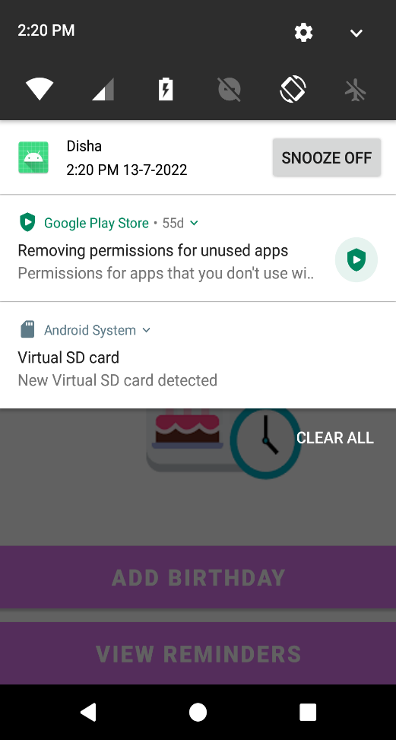

The "Notification" page empowers you to tailor your birthday reminder notifications to suit your preferences. Customize the following settings:

Notification Type: Choose the type of notification you want to receive when a birthday reminder occurs. Options may include sound, vibration, or silent notifications.

Frequency: If you have multiple birthdays on the same day, set the frequency of reminders to ensure you receive notifications for all the relevant birthdays.

***8.Conclusion:***

Congratulations! You've now gained a comprehensive understanding of the Birthday Reminder Application and its functionalities. By using this app, you can effortlessly manage and track all your important birthday reminders, fostering stronger connections with your friends and family. Should you have any questions or feedback, our support team is ready to assist you.

Thank you for choosing the Birthday Reminder Application! We hope it enriches your life with meaningful celebrations and cherished moments.